Chapter 2
Presenting Data in Tables and Charts

Introduction
Raw data is not very informative
Data must be turned into information through tables or charts (and statistics in next chapter)

2.1 Tables and Charts for Categorical Data

The Summary Table

Frequencies
Banking Preference  (Category) | Frequency  (Data)
ATM | 32
Automated or live telephone | 4
Drive-through service at branch | 34
In person at branch | 84
Internet | 50
Total (Always have a total row!) | 204

Percentages
Banking Preference | Percentage (%)
ATM | 16%
Automated or live telephone | 2%
Drive-through service at branch | 17%
In person at branch | 41%
Internet | 24%
Total | 100%

Both
Banking Preference | Frequency | Percentage (%)
ATM | 32 | 16%
Automated or live telephone | 4 | 2%
Drive-through service at branch | 34 | 17%
In person at branch | 84 | 41%
Internet | 50 | 24%
Total | 204 | 100%

2.1 Tables and Charts for Categorical Data

The Bar Chart
Shows frequency by category visually instead of using numbers.  (Although numbers are often added)  Categories are shown on the left or bottom axis.  Frequencies are shown by the length of the bar for each category.  Good for comparing the relative frequencies of different categories  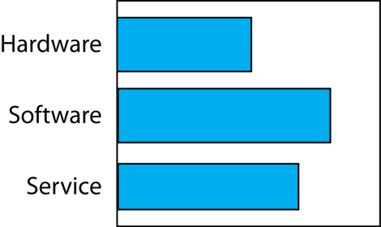 | 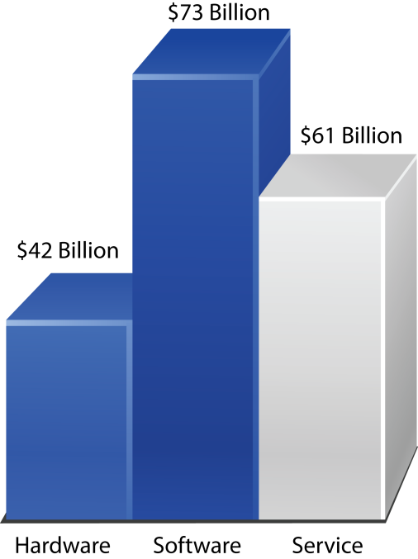

The Pie Chart
Also shows the relative frequency by category visually instead of using numbers.  (Although numbers are often added)  Categories are the slices  Frequencies are the relative fraction of the circumference for each slice.  Good for showing the importance of each category relative to the whole | 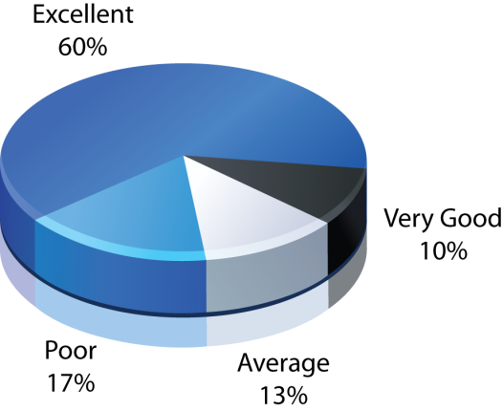

The Pareto Chart

2.2 Organizing Numerical Data

The Ordered Array
An ordered array is sequence of data, in rank order form, from the smallest value to the largest value.
4 8 15 16 23 42
Not too useful by itself, but often a first step in analyzing numerical data.

The Stem-and-Leaf Display

2.3 Tables and Charts for Numerical Data

Note
Data often must be grouped into numerically ordered classes
For example, Age variable data might be grouped into Under 21, 21 but under 35,35 but under 50, etc.
Boundaries must be well-defined. (In what category do you put 35?)

The Frequency Distribution
Frequency distribution is a summary table in which the data is arranged into numerically ordered classes.  The width of a class interval is the range (highest minus lowest) divided by the number of classes.  If the range is 52 and there are 10 classes, then the width of a class interval is 5 (round it off).  However, class intervals may be unequal.  The class midpoint is the values half way between the highest and the lowest in a class.  Should be at least 5 classes but no more than 15 to present meaningful information.  (You would not show a frequency distribution of age by individual years, for example. There would be too few people in each age class interval to be meaningful.) | Classes
  Project Team Size | Number of Teams
  2 | 0
  3 to 5 | 26
  6 to 8 | 37
  9 to 11 | 12
  12 to 20 | 6
  Over 20 | 12
  Total | 98

The Relative Frequency Distribution versus the Percentage Distribution
For the frequencies, the frequency for a class is the number of items in the class.
Proportion in each class = frequency in each class / total number of values
Relative frequency is another term for proportion
Proportion/relative frequency is typically shown as a percentage
Cost per Meal | Proportion | Percentage  (Relative Frequency)
0 but less than 5 | 0.02 | 2%
5 but less than 10 | 0.04 | 4%
10 but less than 20 | 0.11 | 11%
20 but less than 30 | 0.18 | ?
N = 98

The Cumulative Distribution
Each class value is the frequency in the class plus the cumulative frequency in the previous class.
Cost per Meal | Percentage | Cumulative  Percentage
0 but less than 5 | 2% | 2%
5 but less than 10 | 4% | 6%
10 but less than 20 | 11% | 17%
20 but less than 30 | 18% | ?

The Histogram
A histogram is a bar chart for grouped numerical data in which the frequencies or percentages of each group of numerical data are represented as individual vertical bars.  Variable of interest categories are shown on the horizontal axis (X axis).  Midpoints are often used to label categories. So if the category is 1 to 3, 2 might be shown as the horizontal category label.  Frequencies are shown on the vertical access (Y axis)  There are no spaces between categories as there are in bar charts for category data.  Not good for showing histograms of multiple variables on the same chart. | 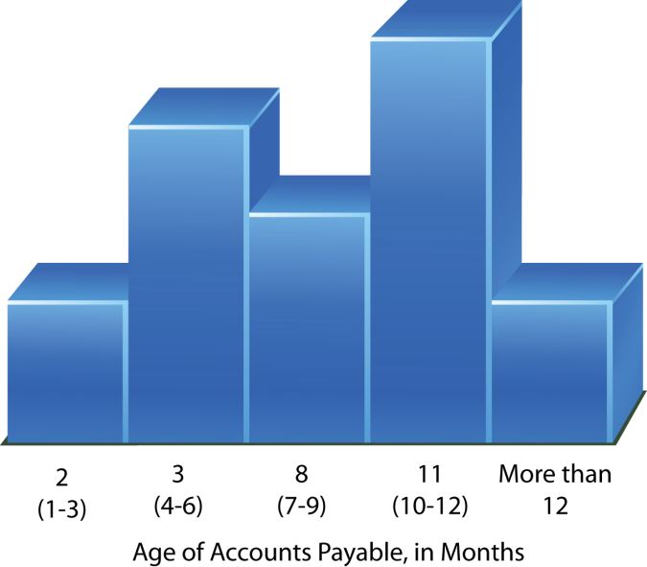
Bar charts are for categorical data categories.
Histograms are for grouped numerical data.

The Polygon (Line Chart)
A frequency polygon is formed by having the midpoint of each class represent the data in that class and then connecting the sequence of midpoints at midpoint frequency value.  A percentage polygon is formed by having the midpoint of each class represent the data in that class and then connecting the sequence of midpoints at their respective class percentages  Good for comparing multiple variables. | 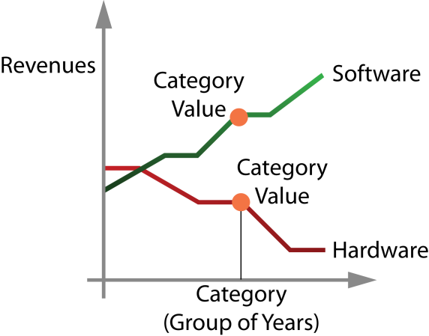

The Cumulative Percentage Polygon (Ogive)

2.4 Cross Tabulations (Contingency Tables)
A contingency table presents the results of two categorical variables as a cross tabulation. The joint responses are classified so that the categories of one variable are located in the rows and the categories of the other variable are located in the columns.

Raw Data (Not Very Illuminating)
 | Level of Risk Category (Vertical Columns)
Objective Category (Horizontal Rows) | High Risk | Average Risk | Low Risk | Total
Growth | 302 | 140 | 22 | 464
Value | 53 | 171 | 180 | 404
Total | 355 | 311 | 203 | 868

Percentage of Overall Total
 | Level of Risk Category (Vertical Columns)
Objective Category (Horizontal Rows) | High Risk | Average Risk | Low Risk | Total
Growth | 35% | 16% | 3% | 53%
Value | 6% | 20% | 21% | 47%
Total | 41% | 36% | 24% | 100%

Percentage of Row Total
 | Level of Risk Category (Vertical Columns)
Objective Category (Horizontal Rows) | High Risk | Average Risk | Low Risk | Total
Growth | 65% | 30% | 5% | 100%
Value | 13% | 42% | 45% | 100%
Total | 41% | 36% | 23% | 100%

Percentage of Column Total (Most Common)

 | Level of Risk Category (Vertical Columns)
Objective Category (Horizontal Rows) | High Risk | Average Risk | Low Risk | Total
Growth | 85% | 45% | 11% | 53%
Value | 15% | 55% | 89% | 47%
Total | 100% | 100% | 100% | 100%

Undergraduate versus Graduate Fund Selection
Research Issue: How do undergrads and grad students differ in fund selection for funds that are identical except for their fees?
What do you total to 100%?
 | Student Group
Fund | Undergraduate | MBA | Total
Lowest Fee | 19 | 37 | 56
Second-Lowest Fee | 37 | 41 | 78
Third-Lowest Fee | 17 | 47 | 64
Highest Fee | 27 | 35 | 62
Total | 100 | 200 | 300

2.5 Scatter Plots and Time-Series Plots

The Scatter Plot
Shows the actual data as individual (ungrouped) data points for two variables.  May draw a best-fit line.  Good for showing the details of the data distribution.  Good for showing the data spread.  Good for showing the data trend.  Good for identifying outliers for further analysis. | 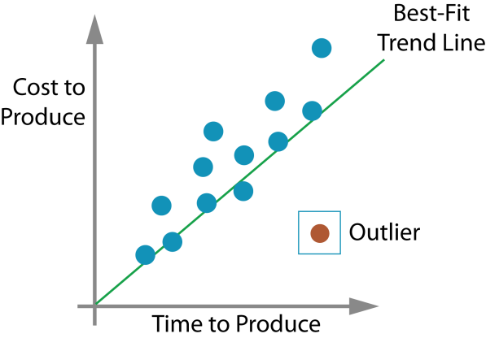

The Time Series Plot
Also for two variables, but the horizontal variable must be time.  The horizontal axis (X axis) is time.  May include trend line and a forecast.  Good for showing trends over time.  May be used to make a forecast (carefully) | 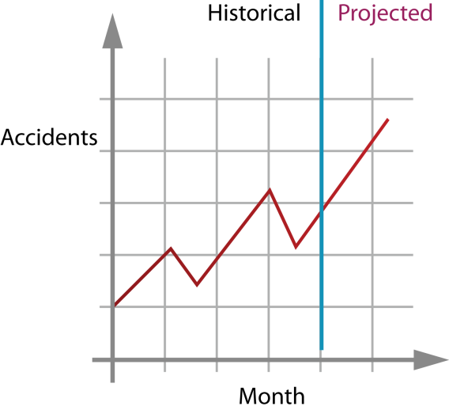

2.6 Misusing Graphs and Ethical Issues
“There are lies, damned lies, and statistics.”
Benjamin Disraeli, British Prime Minister.

Graphs can be misleading
When showing money and other quantitative data, make the lowest value of the X-axis Zero (0)
If you make it higher, percentage differences between series and changes over time will seem larger that they really are.
Having some series with a zero lowest X-axis and other a higher lowest X axis is highly misleading.

Guidelines for Graphing
Honesty
The graph should not distort the data.
Simplicity
No chart junk (unnecessary adornments that convey no useful information)
You should create the simplest possible graph that will convey the data.
Labeling
Any 2D graph should contain a scale for each axis.
The scale on the vertical axis should begin at zero (0).
All axes should be properly labeled.
The graph should contain a title.
Include the sample size.
Added: Create a graph that addresses the business question!!

Ethical Concerns
Presenting in a way that fools the audience (not having a zero on the vertical axis).
Added: Deliberately falsifying the data.
Added: Make hidden assumptions that bolster your case.
Added: Only show the data that supports your case when there is contrary data.

Types of Data and Types of Analysis
Type of Analysis | Numerical Data | Categorical Data
Tabulating, organizing, and graphically presenting values of a single variable. | For a single grouped numerical variable  Frequency distribution and relative frequency distribution  Histogram  Polygon (line chart)  Ordered array  Stem-and-leaf,  Cumulative percentage distribution,  Cumulative percentage polygon. | For a single categorical ordered or unordered variable  Summary table  Bar chart,  Pie chart,  Pareto chart.
Graphically presenting the relationship between two variables. | For two variables  Ungrouped  Scatter plot  Grouped  Time-series plot | For two variables.  Contingency tables (cross tabs)
Chapter 3: Summary statistics (single numbers that characterize a variable’s distribution) | For a single variable:  Mean,  Median,  Mode,  Standard deviation,  Variance. | For a single variable:  Mode.  Median if ordered categorical data.
In general | Rich set of options. | Limited set of options.

